



**Government of Malawi**

**LESSONS FROM AGRICULTURAL RESOURCE CENTRES**

**SUSTAINABLE AGRICULTURE PRODUCTION PROGRAMME (SAPP)**

**MAY, 2019**

**INTRODUCTION**

The global agricultural food industry relies on smallholder farmers. Despite this, many smallholder farmers who produce food for global supply chains lack the agriculture market and technical information. Various studies undertaken in Malawi demonstrate that the production, dissemination, and access to technical and marketing information are not effectively and efficiently done to reach end users, in this case, all value chain players in the agriculture production, smallholder farmers, not exception. In an effort to address the agricultural marketing and technical information gap, the Ministry of Agriculture Irrigation and Water Development (MoAIWD) through Sustainable Agriculture Production Programme established Agricultural Resources Centres (ARCs) as a solution in promotion of access to agricultural marketing and technical information in six districts of Malawi. The districts are, Lilongwe, Nkhotakota, Chitipa, Balaka, Blantyre, and Chiradzulu.

An Agricultural Resource Centre is a place where agricultural information is gathered, processed, equitably accessed and disseminated for the purpose of decision making in relation to choice and application of technology, target market, the timing of sales and storage to enhance agricultural growth and development. The overall purpose of establishing agricultural resource centres in agricultural development and extension is to promote access to agricultural marketing and technical information to increase agricultural production and promote agribusiness enterprises. The specific reasons for establishing ARCs are the following:

1. Provide market outlet and price information for informed production and investment decisions.
2. Provide information on appropriate methods for the production of crops, fish, and livestock.
3. Increase access to agricultural services.
4. Provide a forum for linking information users to information providers across the agricultural sector.

The ARC is ‘one stop shop’ of extension information, in the following categories: business management (marketing, financial management); agricultural production (crops, livestock and fish); soil fertility and land management; water conservation and management; research publications on new technologies; extension materials; marketing information; statistical data on various agricultural programmes; farmers organizations profiles; agro-industry profiles; policy documents and demonstration units.

**Methodology**

## The implementation of the ARC is coordinated by the Ministry of Agriculture, Irrigation and Water Development using the existing institutional arrangements. However, in order to ensure smooth operationalization and sustainability of the ARCs, stakeholders within the communities are empowered to manage ARCs. There are different steps for establishing ARCs, the common steps used by the MoAIWD are the following:

1. **Sensitisation of key stakeholders**

This is the first step in the establishment of ARCs. Promotion of ARCs concept is of the utmost importance. An Agricultural Resource Centre will not succeed unless it is fully understood and welcomed by all stakeholders from the national up to the community levels.

1. **Community Sensitisation;**

After stakeholder sensitisation, community sensitisation follows. To do this successfully, the leaders must be very clear about the values and benefits of the ARC.

1. **Site Identification and the election of office bearers**

Not all places in the EPA are suitable for ARCs. The district and EPA facilitation teams are oriented on selection criteria for EPAs. It has to be highlighted that there is a need to have enough office and demonstration space. The next step after identifying the site is to elect office bearers.

1. **Rehabilitation or construction of a building.**

Identified sites which are deemed unfit for normal occupation and functioning of the centre, rehabilitation is necessary.

1. **Capacity building**

The Committees are trained in areas of group dynamics, group management, ARC establishment, ARC management and other relevant topics as they arise during implementation.

1. **Establishment of resource centre bank account**

Once the management committee has been put in place, the ARC opens and runs a bank account by following standard procedures stipulated in the implementation manual.

1. **Agricultural demonstration and market information notice board**

Demonstrations on various agro-based technologies form an integral part of ARCs as well as displaying market price information of various commodities within the community and nation.

1. **Personnel identification.**

The district team identifies a person to manage the ARC. The chosen person is responsible for advice, but the day to day management of the ARC rise in the hands of ARC management committee.

1. **Stocking of the ARC.**

Various sources will be used to equip the ARC.

**SAPP ESTABLISHMENT AND MANAGEMENT OF ARCS**

Sustainable Agricultural Production Programme uses ARCs as one of the extension approaches in agricultural marketing and technical information to smallholder farmers in six districts of Chitipa, Nkhotakota, Lilongwe, Balaka, Chiradzulu and Blantyre in Malawi. The project relies on District Agriculture Development Offices for the establishment and management of the ARCs. The following steps were followed by SAPP when establishing ARCs in the six districts it is working.

1. **Sensitisation of key stakeholders**

The first step the project undertook was sensitisation of district staff which comprised of District Agriculture Development Officers, subject matter specialists of different departments (extension, crops development, animal health and livestock development, land resources and conservation). The district staff, in turn, sensitised frontline staff and community leaders at EPAs and sections in each district. The sensitisation of stakeholders at EPAs and sections aimed at creating awareness of the value and benefits of ARCs.

**ii. Community Sensitisation**

The frontline staff together with traditional leaders organised community meetings for community sensitisation. Community meetings were conducted at section level as well as EPA. The main aim of community sensitisation was for the community members to own the approach after fully understanding the importance of such an initiative at the community level.

1. **Site identification and the election of office bearers**

After community sensitisation were done in all the EPAs and sections in each district. An open selection of ARC management committee members was done in EPAs. The identification of land in sections was done during sensitisation meetings and at the open air for transparency and accountability. The process of selecting members of the ARC management committee was followed with identification of ARCs site. For the EPAs, almost all the districts chose EPA premises. This was the case based on the understanding that the housing for stocking print and electronic material was already in place as well as plots for demonstration. For the sections, traditional leaders provided land for construction of a library and establishment of demonstration plot.

**iv. Rehabilitation or construction of a building.**

Identified sites which were deemed unfit for normal occupation and functioning of the centre were rehabilitated using community resources. The community made fittings of bookshelves for the house provided at EPAs and those constructed at sections.

**v. Capacity building**

The ARC management committees were trained in areas of group dynamics, group management, ARC establishment, ARC management and other relevant topics as they arise during implementation. The community members were also told to come up with the constitution of the group. Office bearers for the executive post of the management committee were also elected during the capacity building training. The training was facilitated by frontline staff who were trained by the district agriculture office and Agriculture Development Division (ADD) staff.

**vi. Establishment of resource centre bank account**

Opening of ARC bank account followed after capacity building. The ARC management committees were encouraged during capacity building to explore various ventures of income-generating activities that can help to sustain the group and bank account. The facilitators also highlighted that resources realized through income generating activities should be used for purchasing inputs for demonstration.

**vii. Agricultural demonstration and market information notice board**

The ARCs management committee cleared the land for demonstration plots and erected a market information board at the ARC site. The demonstration plots were mainly for crops and land resources. Some ARCs even went further establishing demonstration plots for livestock such as standard goat kholas and chicken pen. The ARCs also erect a board which displays market information for the local markets and national markets.

**Viii. Personnel identification**

The district in liaison with Agriculture Extension Coordination Officer nominated an agriculture staff for the post of ARC manager. The officer’s main task was an advisory role and coordination of ARCs management committee with the office. However, the day to day management and decision-making concerning ARCs were in the hands of ARC management committee.

1. **Stocking of the ARC**

The established ARCs were stocked with publications from different institutions that are working in the country. Some ARCs were also linked with National Library Service for easy access to books and other publications. The management committees were also encouraged to document, publish and stock results of the demonstrations in the resource centre library.

**LESSONS LEARNT**

The few years the Ministry of Agriculture, Irrigation and Water Development through Sustainable Agricultural Production Programme, (SAPP) has been implementing ARCs concept, lessons have been drawn. Below are a few sampled lessons from the field.

1. **Increased adoption of good agricultural practices among the smallholder farmers in communities that access ARC services**

The ARCs which were established by SAPP in the six districts, mounted demonstration plots of various crop varieties, crop practices and management, pest control and management. The ARCs conducted field days at least three times for the technologies they were demonstrating on the mounted plots. During the field days, farmers were asked to choose preferred technologies and practices that were favourable to their local condition and their context. The following year showed that half of the farmers who attended field days in the previous season adopted one or more practices and crop varieties which were demonstrated during field days. In Chiradzulu District in Thumbwe, Mombezi and Mbulumbuzi EPAs in 2017/2018 season, demonstration plots were mounted on crops and different practices. The demonstrations were on manure making and application, herbal garden, cotton, pearl millet, orange fresh sweet potato varieties, contour marker ridge and ridge alignment, maize varieties and agro-forestry. In 2018/2019season, out of 3820 farmers who accessed resource centre services in the previous season, two third of them made manure and applied in their fields, one third planted pearl millet, half planted orange fresh sweet potato, two third grew early maturing and drought tolerant maize varieties.

In Lirangwe EPA, Blantyre District, farmers adopted various technologies and practices based on demonstration mounted by the resource centre in 2017/2018. In the 2018/2019 growing season, the EPA experienced an increase in the number of adoptions as follows; 66 farmers (21 male and 45 female) adopted double-up legume-soya technology, 104 farmers (33 male and 71 female) adopted maize inter-planted with p/peas, 127 farmers (55 female and 72 male) groundnuts interplanted with p/peas and 82 farmers (31male and 51 female) adopted soya interplanted with p/peas.

1. **Adoption of good agricultural practices and technologies without interfacing with extension workers**

In Lilongwe East, 1683 farmers (632 males, 1051 females) across six EPAs of Chitsime, Mpenu, Chitekwere, Chigonthi, Nyanja and Mkwinda have adopted various technologies and practices without direct contact with extension workers. For instance, Nyanja EPA alone,15 female farmers started small stock farming after reading a publication on poultry farming. In the same EPA, more than 300 farmers are doing conservation farming after reading the literature of conservation farming. More than 41 farmers have started agro-forestry after reading about agro-forestry. The farmers formed a group and established a tree nursery by using a guiding manual of tree nursery establishment they found in the resource centre library.

1. **Farmers finding markets through ARCs**

Some EPAs erect market information board of different crops and commodities within their locality and neighbouring districts. The information has helped farmers to make a decision of where and when to sell. Rajabu Joni from Chiwundo Village T/A Namkumba, Ulongwe EPA in Balaka District is one of 300 farmers who have found markets through ARCs in Balaka. In 2016/2017 season Rajabu Joni started visiting Namkumba RC that is supported under SAPP in Utale EPA with the aim of accessing agricultural information and he came across market information for different crops within the district and neighbouring districts. Joni started following markets where he could sale produce at higher prices instead of waiting for traders to come to his village to dictate prices. The commodity traders were offering MK90 for a kg of maize, but Rajabu Joni sold his maize at MK220per Kilogramme in 2017/2018 season.

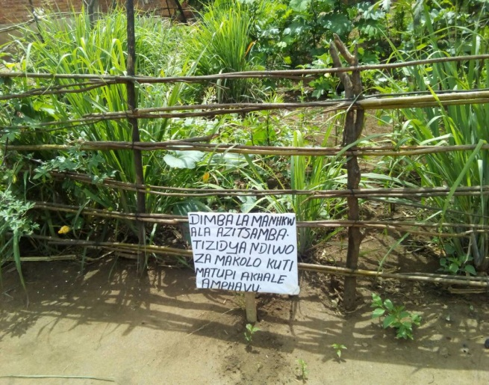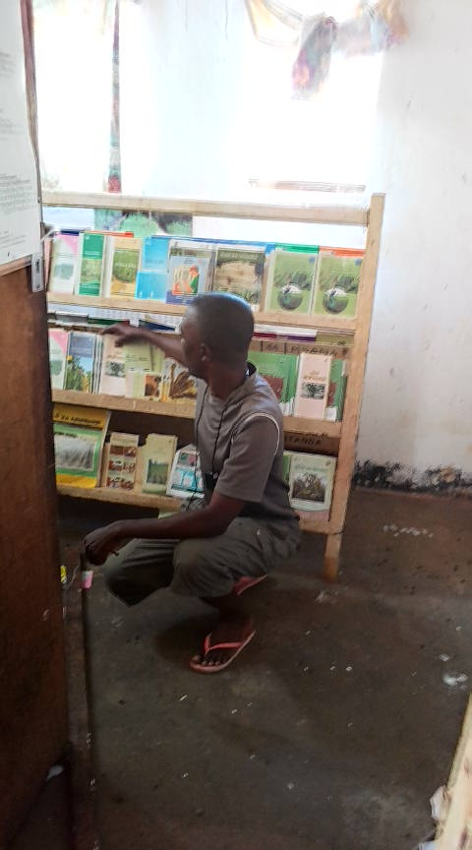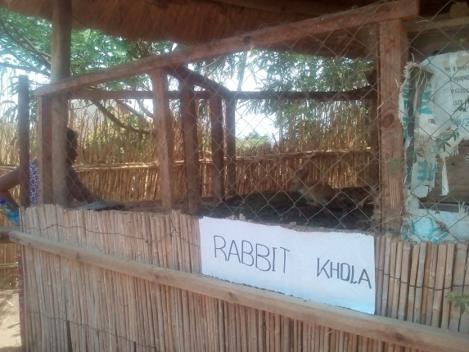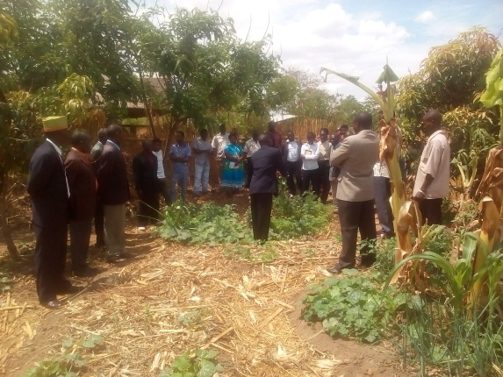*Rabbit khola and Permaculture at Landilani ARC in Chigonthi EPA*

*Nutrition and Herbal garden and library at Chitsime EPA resource centre*