**LESSONS FROM LIVESTOCK**

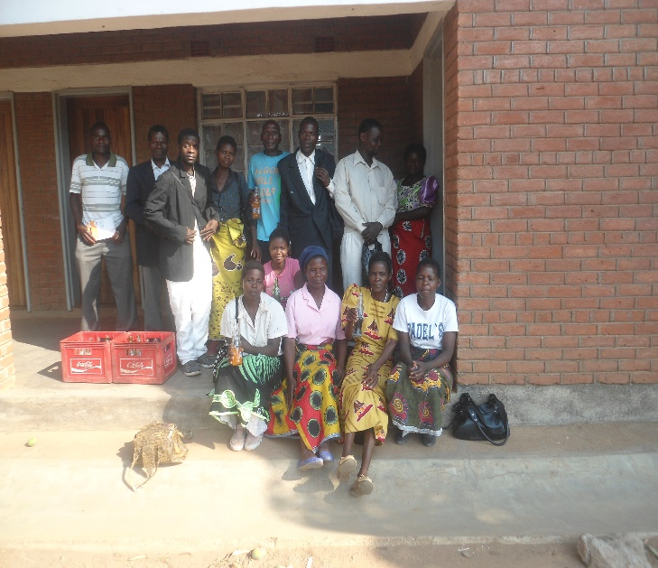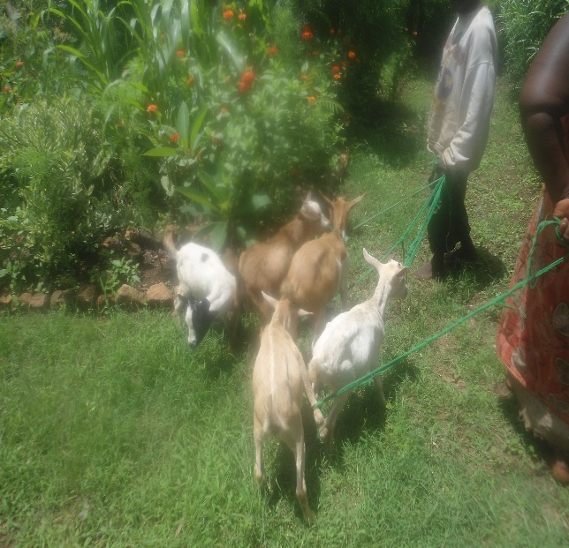

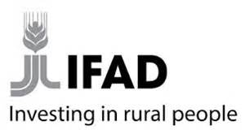

**SUSTAINABLE AGRICULTURE PRODUCTION PROGRAMME**

**MAY 2019**

**TABLE OF CONTENTS**

**1.** Introduction ……………………………………………………………………1

2. Objectives……………………………………………………………………...1

3. Methodology……………………………………………………………….......1

4. Lessons Learnt………………………………………………………………….4

5. Success Stories..................................................................................................................5

**1.0 INTRODUCTION**

Small Stock Livestock Production is one of the sub components in component 2 of SAPP work plan and budget. It falls under access to agricultural inputs. The programme distributes goats and chickens on pass on the offspring concept. Therefore the programme is promoting good agricultural practices through improved kholas; good feed and feeding management; breeding management and disease control. The programme has with this intervention reached 4,984 goat farmers and 4,725 chicken farmers that have each constructed an improved standard livestock house/khola. The total number of livestock bought and distributed to beneficiaries by December, 2018 was 24,921 goats and 47,250 chickens. The programme has also distributed 56 goat drug boxes and 69 chicken drug boxes.

**Objectives**

* To improve soil health for high productivity.
* To increase household ownership of goats and chickens.
* To create wealth by generating income through livestock sales at household level.
* To increase dietary intake of animal protein through the consumption of livestock and livestock products.

**2.0 METHODOLOGY**

**Beneficiaries’ identification and group formation:** The programme is executed firstly by sensitising the rural communities, then mobilizing interested individuals to form groups of 15 members. Therefore the programme has goat and chicken groups. No group benefits from both livestock species.

**Capacity building:** The groups are then trained in small stock management, group dynamics and leadership before receiving the animals.

**Improved standard khola construction:** After the training, the beneficiaries are instructed to organise khola construction materials. Then demonstration kholas are constructed under the supervision of an Assistant Veterinary Officer (AVO).The beneficiaries construct their kholas and in some instances, group synergy is used where the beneficiaries work as a team to construct each khola for the rest of 14 members as a group.

**Number of goats per beneficiary***:* The programme then procures small stock and distributes to beneficiaries as shown in figure one below. Interms of goats, five goats (1 male (buck) and four female goats (does)) are distributed to each beneficiary.

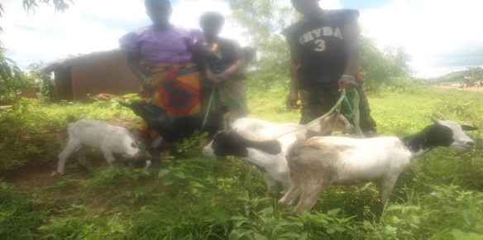

**Figure 1: shows a beneficiary receiving five goats at Moto Village, Mombezi EPA**

**Number of chickens per beneficiary:**10 chickens (1 cock and 9 pullets) are also distributed to each beneficiary.

**Agreement forms:** Agreement forms were designed and produced for the beneficiaries to sign a pass-on agreement before receiving the goats. The agreement form binds the beneficiary to rules and regulations that govern the pass-on programme. The beneficiaries also sign beneficiary form on receiving the animals.

**Drug boxes:** Each group has been provided with a drug box full of different drugs depending on diseases prevailing in those areas. Types of drug boxes depend on livestock species received. Therefore there are goat and chicken drug boxes. All the 44 groups in the districts have a drug box for a revolving fund as shown in picture below.

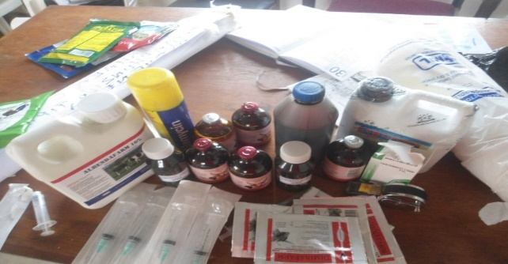

***Figure 2: Some of the drugs distributed to groups***

**Pass on modality:**

a) **For goats:** Each beneficiary that receives five goats (1 male and 4 female goats) shall pass on five goat off-springs, when they kid, to next beneficiary using the same ratio (See figure 3)

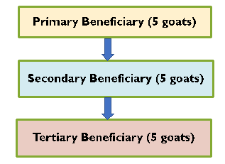

**Figure 3:** Pass on modality for goats.

b) **For chickens:** When the hens have hatched, then the beneficiary passes on 20 chickens (18 pullets and 2 cocks) to two beneficiaries who get 10 each (1 cock and 9 pullets) as shown in Figure 4 . Chickens multiply fast as they have a short generation interval and more hatches per clutch.

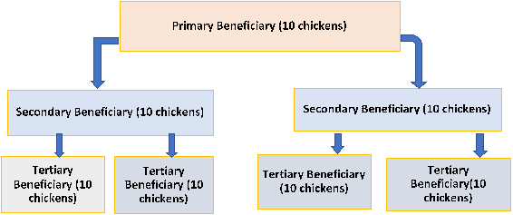

**Figure 4:** Pass on modality for chickens

The intervention is scaled up by the concept of pass-on as alluded to in figures shown.

.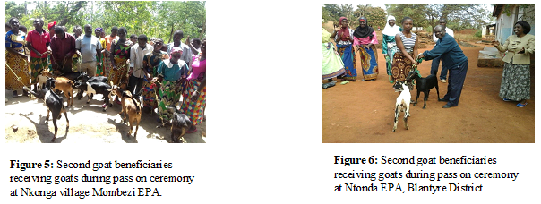

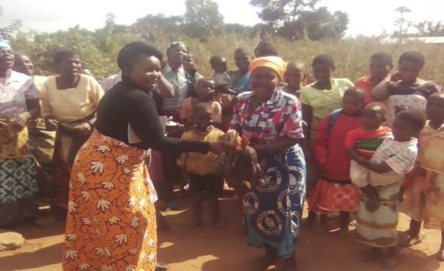

**Figure 7:** The EMO giving chickens to second beneficiary at Nakoli village

Mbulumbuzi EPA

**Financial and technical support:**SAPP has provided financial support for procurement of small stock livestock, drugs, capacity building for both farmers and staff. All activities including field days, supervision and monitoring are financed by SAPP.

**3.0 LESSONS LEARNT**

* Good agricultural practices (basket chick rearing technology and supplementary feeding) help in fast multiplication of indigenous chickens resulting into quick pass on of the chickens to next beneficiaries within the shortest period possible.
* The pass-on programme is progressing exceptionally well where there is good leadership (village heads, lead farmers) plus involvement of the DAES structures such as VAC, VDC, and ADCs. At national level Total number of chickens that have been passed on to next beneficiaries has risen to 38,912 by December, 2018 translating into MK116, 736,000 when considering an average price of MK3000 per chicken. For goats, 8058 goats have been passed on at national level translating into MK201,450,000 considering an average price of MK25,000 per goat. This a lot of money that has been realised within three years that Department of Animal Health and Livestock Development (DAHLD) has been in the project.
* Incidences of Newcastle disease have drastically reduced due to regular vaccination campaigns. For example, in Nakoli Village, they received 150 chickens in 2016. After hatching the chickens have increased up to 961 as at December, 2018. But they have also sold 478 and consumed 119 chickens.
* Farmers now appreciate the concept of attaching value to their livestock and feel the loss of an animal as a loss of so much money. For example Chiradzulu District has registered a growth rate of 48per cent in goat production and 133 per cent in local chicken production under SAPP. From the initial population of 1,850 to the current population of 3,194 in Chiradzulu District alone. In monetary connotations, at the local price of MK 25,000/ goat from MK 46,250,000 to MK79, 850,000 with increases due to births (1,078 kids) and the recent distribution.
* Scarcity of local khola construction materials mainly for goat’s kholas resulted in beneficiaries constructing poor kholas. Farmers have been advised to start planting agro-forestry trees that could offer feeds, improve soil fertility and be used as khola construction materials.
* A combination of CA technology and animal manure has had a positive effect in that fields with CA technology in combination with animal manure had impressive yield while the neighbouring fields where they did not follow the technology had low yield. For example, Mrs Angella Banda of Nakoli, Chiradzulu has harvested 46 bags of 50kg maize in 2018 fiscal year after applying manure plus fertilizer.
* There is need to vet the groups that are formed to indulge in livestock production.
* Livestock distributed to some poor resource individuals end up being sold and reported as deaths.
* Adults learn better when they see their fellows doing it (the concept of seeing is believing).
* There are also continued constraints that have been observed by farmers being reluctant to pass on the animals that they received to continue the pass on chain which slows down the progress and impact of the programme.
* The standard khola technology is widely being followed within the district. But we still have some farmers who still keep the small stock in their residential housing for security reasons. The smallholder farmers fear that the goats and chickens will be stolen.
* Crop/livestock diversification is key to sustainable agricultural production at household level. The risk of failure at household level is reduced when households diversify. Crops need livestock manure and livestock need crop residues and by products. There is high level nutrient recycling that is good for soil health.

**4.0 SUCCESS STORIES**

The implementation of livestock activities under the SAP programme has registered some success stories as follows;

* 1. ***Mr Gabriel Biyo of Chingwengwe Goat club, in Lunga 1 section in Mphonde EPA.***
* Received 5 goats in 2016, paid back his 5 goats loan in 2017
* In 2017/18 season sold 9 goats, proceeds bought farm inputs i.e. fertilizers soya bean and maize seed
* Harvested and sold them at around K1,000,000.00
* Bought a motorcycle worth K550,000.00

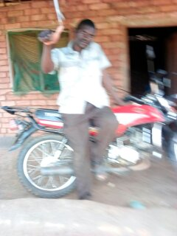

**Figure 8:** Mr Biyo with his motorcycle

* Now he has 7 goats
  1. ***Angela Banda of Nakoli Village in Chiradzulu district:***

Angela Banda received 10 chickens from SAPP. After passing on 20 chickens to next beneficiaries, she sold some chickens and bought a doe goat early 2017. The goat kidded twice. To-date she has five goats. She is able to pay school fees from the sales of chickens and eggs, for her son who is doing form 4 at Chiperere CDSS.